Final Research Paper:
“The Gender Pay Gap and Inequality of Women Athletes and Female Sport Industry Employees On and Off the Playing Field”
Nicholas Woolfolk
Dr. Carroll
Sport and the Law
7/24/22
Plagiarism Statement:
By typing my initials below, I hereby declare that this paper is solely my work. I did not copy and paste any content into this paper, nor did I use any other student’s work. Furthermore, I have not used any of the content in this paper in any other course. Any evidence to the contrary, and I understand that I will receive an automatic zero on this paper, an F in the course, and possible expulsion from the SFM program.

Type Initials Here: NVCW
Introduction
The gender pay gap issue has been front and center in the sports world especially since the recent Women’s National Soccer Team lawsuit in February 2022 which awarded a $24 million settlement to the plaintiffs as well as a commitment from the US Soccer Federation to pay on an equal scale for both the women’s and men’s national soccer teams going forward (Bonn, 2022).
Even as significant as this victory is in the discussion of gender equality and pay in the sports industry, it will take many more years of policy changes, grass root efforts, exposure of inequities and fan popularity before professional women athletes will enjoy equitable financial scenarios and advancement opportunities as that of their male counterparts. But don’t discount the importance of this case and other cases that came before in the slow and complicated changes that are needed on the field and behind the scenes of women’s professional sports organizations.
Statement of Problem/Issue
Traditionally, men’s sports have dominated American fandom and society favoring the white male college and professional athlete. Only in the last 75 years have women and minorities been permitted to participate in professional sports as athletes and more recently in the sports business arena as employees and executives. And while there may have been women and African-American sports leagues in the 1920’s and 1940’s certainly there was no parody in pay scale, media coverage or endorsement opportunities. Women did get paid while participating in the All-American Girls Professional Baseball League which started in 1943 but very little (Francis). The Negro National League started in 1920 but was plagued with mismanagement and sometime getting paid was a challenge (Kelly).
How do we explain the disparity? In a sense, men have had a head start because men’s sports were predominantly covered by the media which highlighted outstanding athletes, teams and the organizations behind them in both collegiate and professional sports. This situation ultimately allowed for a system which created mega salaries, huge endorsement deals and executive positions within the industry for men (“Examining the gender”).
Two of the oldest professional sports leagues in America are the NFL (National Football League) and MLB (Major League Baseball) with both making arguments that they were the first professional sports leagues in the country. The MLB claims professional baseball started back in 1876 while the NFL says they began in 1896. Regardless of their start date, by the turn of the 20th century professional sports in America was well on its way, at least for the white male. So, the issue is not only that women athletes and female employees in the sports industry are underpaid but for so many years women were not even encouraged or allowed to participate and if they did it was mainly on a select few college campuses or in high school.
Women were not even granted permission to participate in the Olympic Games officially until 1908 although there were some women exhibition sports in the 1900 and 1904 Olympic games. Only in the last twenty years or so have we seen multi-million-dollar salaries and endorsement deals for women mainly in tennis, soccer and golf but the number of these top paid women is grossly lacking when compared to the number of multi-million-dollar male athletes.
Literature Review
Change on the field and inside various sports programs may have never come had it not been for important and groundbreaking court cases that researched, studied, analyzed and argued the law and women’s right to have equal programs and facilities and in some cases, pay.
The recent USWNT v U S Soccer Federation finding is credited with bringing the pay disparity issue to light. The US Women's Soccer team had more victories, accolades and grossed more revenue than the men’s team yet they were not compensated in the same manner. Before going to the 2019 Women’s World Cup in France 28 players decided to file a class-action lawsuit against the US Soccer Federation in March of 2019 saying gender discrimination was at play which accounted for a significant difference in compensation in relation to what the men’s team was getting. Alex Morgan, one of the team’s superstars, argued that their success on the field which resulted in three World Cup championships, was not accurately reflected on an even scale when comparing the pay structure to the men's side (Bonn, 2022). Morgan v. United States Soccer Fed'n, 25 F.4th 1102 (U.S. 9th Cir. 2022)
The plaintiffs were awarded $24 million in a settlement that was announced on February 22, 2022 and just this past May a collective bargaining agreement (CBA) between the United States Soccer Federation and the women’s team was agreed on which will allow for equal pay (“U.S. Soccer Federation”).
In 1969, Bernice Resnick Sandler, a 41-year-old doctoral candidate, had difficulty obtaining an interview for a tenure position at the University of Maryland which was where she was already employed. Sandler felt that this was an act of sex discrimination because she was just as qualified as her male contemporaries but was not afforded the same opportunity simply because she was a woman. She partnered with the Women’s Equity Action League to gather information and testimony regarding sex discrimination that was taking place in universities and colleges in the United States. As a result of this, over 250 complaints were filed against colleges and universities with the Department of Labor. This organized operation is credited with addressing sex discrimination and eventually helped to pass Title IX that prohibits sex discrimination in any school or educational program that receives federal funding (McShane, 2022). The actual verbiage of Title IX of the Education Amendments of 1972 states: “No person in the United States shall, on the basis of sex, be excluded from participation in, be denied the benefits of, or be subjected to discrimination under any education program or activity receiving Federal financial assistance” (“Title IX”).
Twelve-year-old Maria Pepe became the first girl to play baseball in Little League in 1972 in Hoboken, New Jersey. She made the team as a pitcher but was forced to stop playing since girls were not allowed to play according to the rules of Little League. Her story went national and the National Organization for Women (NOW) joined Pepe and filed with the New Jersey Division of Civil Rights claiming that Little League was discriminating against her because she was a girl. Nat'l Org. of Women v. Little League Baseball, Inc., 67 N.J. 320, 338 A.2d 198 (1974). The hearing officer ruled in favor of Pepe, and after the New Jersey Supreme Court upheld the decision in 1974, girls were allowed to play for Little League teams all across the country. Maria Pepe never played in Little League again as she had aged-out by the time the final ruling was announced but if she hadn’t stood up for little girls and the right to play, it may have been many more years before they were able to participate in Little League.
Many sports enthusiasts and scholars alike believe this case had as much influence on the passing of Title IX than any other effort. Douglas E. Abrams, of the University of Missouri School of Law, stated in a faculty publication, “National reaction to Maria Pepe’s courageous insistence on gender equity helped sustain the evolution in gender roles that had accelerated since the Women's Movement of the 1960s. Her landmark legal action also likely influenced the Supreme Court's gradual movement toward intermediate scrutiny of gender discrimination claims; the 1975 federal regulations that assured Title IX of the Education Amendments of 1972 a prominent role in elementary, secondary and higher education; and children ' socialization concerning gender roles in our society” (Abrams).
ESPN (Entertainment and Sports Programming Network) even named Maria Pepe playing Little League baseball and the suit that followed one of the top five Greatest US Women’s Sports Moments (“Greatest U.S. Women’s).
Once Title IX was in place many complaints were filed not only in relation to sexual harassment in an education institution as in the Alexander v. Yale case in educational institutions but also in regards to women’s sports at colleges and universities. Alexander v. Yale Univ., 631 F.2d 178 (2d Cir. 1980).
One case was brought by Rollin Haffer, who attended Temple University and was a varsity badminton player. Haffer along with eight other classmates filed a class-action lawsuit against Temple University in 1982 alleging sex discrimination in women’s intercollegiate sports. Part of her case said that the women’s programs and facilities were not as good as the men’s programs. Six years later the judge in the case ruled that the intent of Title IX applied to all intercollegiate sports programs and Temple University agreed to improve the facilities that the women’s sports teams used as well as to give more funding toward those programs. Haffer v. Temple Univ., 688 F.2d 14 (3d Cir. 1982)
Discussion
Throughout the years several cases have had a major impact on the law surrounding women’s sports and have moved efforts along but has the involvement of girls and women in sports increased because of these cases? According to an article by Richard C Bell, Ed.D., J.D., in The Sport Journal, females have become more active in sports programs in high school and college.
Bell stated, “It can be seen that women’s involvement in sport was slow to develop. Opportunities for participation and recognition were almost non-existent for centuries. It was not until the advent of the equal rights movements and Title IX that women truly found a place as participants in the world of sport and in the public arena.” The article goes on to claim significant increases in participation in sports among females as well as the number of teams offered at colleges and universities (Bell, 2016).
In an article posted by the Women’s Sports Foundation former, President Donna De Varons credits Title IX with staggering increases saying, “Since 1972, thanks to increased funding and institutional opportunities, there has been a 545% increase in the percentage of women playing college sports and a 990% increase in the percentage of women playing high school sports” (Olmstead, 2019).
Although the interest among college and high school women has increased, the salaries of professional women athletes have a long way to go to even come close to the salaries of their male counterparts as seen in the table below which is from an Adelphi University Sports Management article that sourced Forbes Magazine 2010 and 2019 issues of top paid athletes.
Figure 1
Top Paid Female Athletes vs Male Athletes
MEN | 2010 | 2019
 | Tiger Woods $105 million | Lionel Messi $127 million
 | Floyd Mayweather $ 65 million | Cristiano Ronaldo $109 million
 | Kobe Bryant $ 48 million | Neymar $105 million
 | Phil Mickleson $ 46 million | Canelo Alvarez $ 94 million
 | David Beckham $ 43.7 million | Roger Federer $ 93 million
WOMEN | 2010 | 2019
 | Maria Sharapova $ 24.5 million | Serena Williams $ 29.2 million
 | Serena Williams $ 20.2 million | Naomi Osaka $ 24.3 million
 | Venus Williams $ 15.4 million | Angelique Kerber $ 11.8 million
 | Danica Patrick $ 12 million | Simona Halep $ 10.2 million
 | Kim Yu-Na $ 9.7 million | Sloane Stephens $ 9.6 million
Note. Adapted from Wigley, Reed. “Male vs Female Professional Sports Salary Comparison.”
There is also a huge pay gap in the business side of the sports industry among women who are marketing managers, trainers, coaches and executives. PayScale, a compensation software and data company, shared that women working in the business side of sports make .88 cents for every dollar that a man makes.
Figure 2
Job Title | Female Median Pay | Male Median Pay | Cents-on-the-Dollar
Marketing Manager | $53,000 | $60,000 | 88¢
Event Coordinator | $35,800 | $38,800 | 92¢
Athletic Trainer | $40,300 | $42,300 | 95¢
Graphic Designer | $39,800 | $40,100 | 95¢
Operations Manager | $49,100 | $49,300 | 100¢
Note. Adapted from “Martin, Chris. “Is There a Gender Pay Gap in Sports?”

With all of these revelations, should we be shocked to learn that even with the finding of the Haffer case back in 1982, women still are having to deal with subpar facilities? During the NCAA basketball national championships in March of 2021 a female athlete tweeted two photos to capture the extreme difference of how female athletes are still treated unfairly. The photos in the tweet were of the workout facilities the NCAA provided the tournament athletes. One photo was the women’s weight room area which had very little equipment and the other photo was of the men’s area which had multiple workout stations, free weights, training tables and more. The tweet made national news and the NCAA apologized for the terrible mistake (Feinberg, 2021).
Conclusion
Even though things have improved somewhat with women’s opportunities in the sports industry, it could be years before the pay gap narrows significantly and more opportunity in the business side and the locker room is obtainable. As interest in women’s sports continues to grow so will the numbers of those who attend games, watch games on devices and follow teams and players on social media. As all of those things happen, naturally there will be an increase in revenue, sponsorships, endorsements, merchandising and therefore more money to pay female athletes and the women who work sports.
Just this past year we have witnessed some advances of female executives and coaches in the sports industry, like Catherine Raiche, the new assistant general manager and vice president of the Cleveland Browns football team operation just this past June (Baca, 2022). Alyssa Nakken made major league baseball history in April earlier this year when she became the first female coach for the San Francisco Giants baseball team (Guardado, 2022).
The law cases presented earlier and those that will no doubt happen in the future, will also help ensure change but without people advocating and standing up for what they believe in, not much will change. If Maria Pepe, Rollin Haffer, Bernice Resnick Sandler and others had not taken the steps to take their complaints to the courts we could be further behind than we are now.
It will take both women and men advocating and pushing for improvement and this can be done outside of the courts too. With grassroots efforts, changing of hiring practices, equitable pay scales in corporate boardrooms, colleges and universities and their athletic associations paying attention to policies and practices, women may one day achieve actual equality in all aspects of their lives. Let’s hope that those in charge will look for the inequities and when they find them, do something about them so that incidents like the NCAA weight room facility debacle will never happen again.
Figure 3
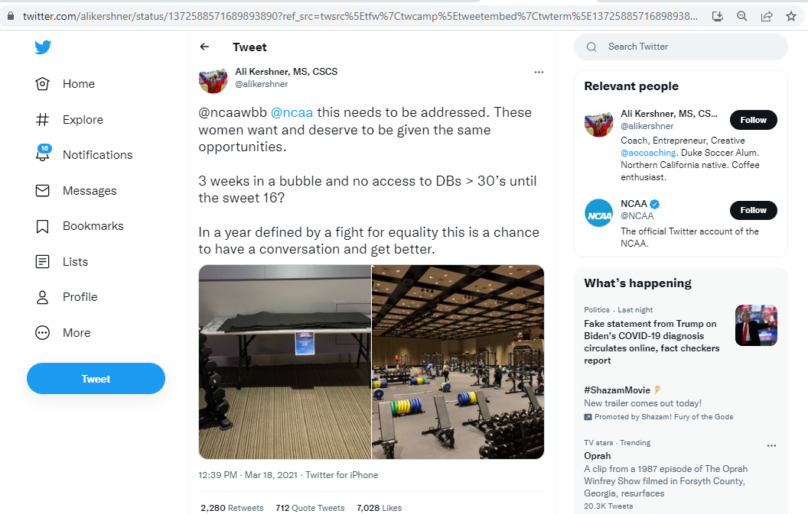
Note. Adapted from Feinberg, Doug. “Differences in Weight Training Facilities Take Center Stage at NCAA Tournaments: 'These Women Want and Deserve to Be given the Same Opportunities'.”

References
Abrams, Douglas E. The Twelve-Year-Old Girl's Lawsuit That Changed America: The Continuing ... https://scholarship.law.missouri.edu/cgi/viewcontent.cgi?article=1505&context=facpubs.
Baca, Michael. “Browns Hire Catherine Raiche as Assistant GM and VP of Football Operations.” NFL.com, NFL, 16 June 2022, https://www.nfl.com/news/browns-hire-catherine-raiche-as-assistant-gm-vp-of-football-operations.
Bell, Richard C. “A History of Women in Sport Prior to Title IX.” The Sport Journal, 12 Oct. 2016, https://thesportjournal.org/article/a-history-of-women-in-sport-prior-to-title-ix/.
Bonn, Kyle. “Uswnt Settles Equal Pay Lawsuit: Explaining Why Women's Team Sued U.S. Soccer and What They Won in Settlement.” Sporting News, 2 Feb. 2022, https://www.sportingnews.com/us/soccer/news/uswnt-equal-pay-soccer-settlement-lawsuit-explain-why-won/ewac7hm1uvjykem5cxkfed.
“Examining the Gender Pay Gap in Sports.” Salary.com, 1 July 2019, https://www.salary.com/articles/examining-the-gender-pay-gap-in-sports/.
Feinberg, Doug. “Differences in Weight Training Facilities Take Center Stage at NCAA Tournaments: 'These Women Want and Deserve to Be given the Same Opportunities'.” Chicago Tribune, 19 Mar. 2021, https://www.chicagotribune.com/sports/college/ct-ncaa-tournament-men-women-20210319-g6pbn3lyuvcoxpqisrq46adpqu-story.html.
Francis, Bill. “League of Women Ballplayers.” Baseball Hall of Fame, https://baseballhall.org/discover-more/stories/baseball-history/league-of-women-ballplayers.
“Greatest U.S. Women's Sport Moments.” ESPN, ESPN Internet Ventures, https://www.espn.com/page2/s/list/moments/uswomen.html.
Guardado, Maria. “First on First: Alyssa Nakken Makes Coaching History.” MLB.com, MLB, 13 Apr. 2022, https://www.mlb.com/news/alyssa-nakken-1st-on-field-woman-coach-in-mlb-history.
Kelly, Matt. “The Negro National League Is Founded.” Baseball Hall of Fame, https://baseballhall.org/discover-more/stories/inside-pitch/negro-national-league-is-founded#:~:text=On%20Feb.,create%20the%20Negro%20National%20League.
Martin, Chris. “Is There a Gender Pay Gap in Sports?” Payscale, 22 May 2018, https://www.payscale.com/research-and-insights/gender-pay-gap-sports/.
McShane, Julianne. “'None of This Was a given': 50 Years of Title IX and Fighting for Equality in US Education.” The Guardian, Guardian News and Media, 13 June 2022, https://www.theguardian.com/artanddesign/2022/jun/13/us-women-discrimination-title-xi-new-york-historical-society.
Olmstead, Maegan. “Title IX and the Rise of Female Athletes in America.” Women's Sports Foundation, 11 Oct. 2019, https://www.womenssportsfoundation.org/education/title-ix-and-the-rise-of-female-athletes-in-america/.
“Title IX and Sex Discrimination.” Home, US Department of Education (ED), 20 Aug. 2021, https://www2.ed.gov/about/offices/list/ocr/docs/tix_dis.html.
“U.S. Soccer Federation, Women's and Men's National Team Unions Agree to Historic Collective Bargaining Agreements.” US Soccer. Sponsored by Volkswagen, 18 May 2022, https://www.ussoccer.com/stories/2022/05/ussf-womens-and-mens-national-team-unions-agree-to-historic-collective-bargaining-agreements.
Wigley, Reed. “Male vs Female Professional Sports Salary Comparison.” Adelphi University Online, 4 Jan. 2022, https://online.adelphi.edu/articles/male-female-sports-salary/

